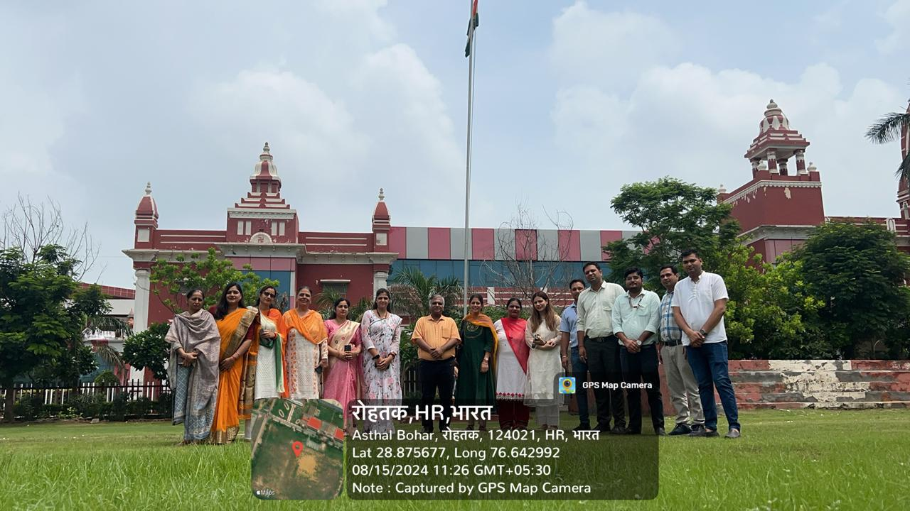**PROPOSED PROGRAMME AYURVEDA WEEK – 2024**

|  |  |  |
| --- | --- | --- |
| **DATE** | **ACTIVITIES** | **COORDINATOR** |
| 18.10.2024 | Health checkup & health Awareness camp at SBMN Sainik School | Dr Amit Yadav, Dr Monika and Dr Gaurav Dalal |
| 19.10.2024 | Health checkup & health Awareness camp at SBMN Residential School | Dr Amit Yadav, Dr Monika and Dr Gaurav Dalal |
| 21.10.2024 | Health Awareness lecture in Humanities College | Dr Gaurav Dalal, Dr Nitin Jain, Dr Rahul |
| 22.10.2024 | Health Awareness lecture in Pharmacy College and science department | Dr Gaurav Dalal, Dr Nitin Jain, Dr Rahul |
| 22.10.2024 | 1. Yogaasana Competition | Dr. Gourav Dalal, Dr. Shikha |
| 1. Awareness Lecture | Dr. Gourav Dalal, Dr. Shikha |
| 1. Plantation | Dr. Pooja Rohilla and Dr. Nitin Jain |
| 23.10.2024 | **Indoor Games**  1. Badminton  2. Table tennis  3. Chess  4. Carrom | Dr Amit Kumar Yadav  Dr Anita  Dr. Rahul  Dr. Nitin Jain  Dr. Rakesh  Dr. Gourav Dalal |
| 24.10.2024, 25.10.2024 | **Outdoor Games**   1. Run (100 M and 200 M) 2. Volley Ball 3. Cricket 4. Throw Ball (for female only) 5. Tug of War 6. Long Jump | Dr Amit Kumar Yadav  Dr Anita  Dr. Rahul  Dr. Nitin Jain  Dr. Rakesh  Dr. Gourav Dalal |
| 26.10.2024, 27.10.2024 | 1. Rangoli competition | Dr. Amrit and Dr. Berkha |
| 2. Poster Competition | Dr. Deepti and Dr. Monika |
| 3. Mehandi Competition | Dr. Preeti and Dr. Sangeeta |
| 4. Flameless cooking and Millet recipe preparation competition | Dr. Austluxmi and Dr. Rakesh |
| 5. Quiz Competition | Dr. Sapna and Dr. Rahul |
| 28.10.2024 | * **Cultural**   1. Solo dance  2. Group dance  3. Poetry  4. Singing  5.Ramp Walk  Prize Distribution Function | Dr. Sonam & All Cultural Committee  Dr Anita  Dr Sapna  Dr Amit  Dr Rahul  Dr Austluxmi |
| 29.10.2024 | 1. Dhanwantri Pooja | Dr. Jagdish Acharya  Dr. Pooja Rohilla  Dr Raj Kailash  Dr. Nisha Jaglan  Dr. Amrit  Dr. Anita Yadav  Dr. Amit Yadav  Dr. Rakesh  Dr. Nitin Jain  Dr. Gourav Dalal |

**Independence day2024 (78th)**

Today we celebrated the78th Independence Day with great enthusiasm and pride. The event began with the hon’ble vice chancellor, prof. H, L. Verma, hoisted the tricolor, accompanied by Registrar Dr. Manoj Verma and Dean Student welfare, Dr. Sudhir Malik.

The spirit of patriotism was further elevated by a remarkable parade performed by our NCC cadets both boys and girls marching in unison. The entire campus resonated with the energy and devotion of our students and staff, who were all present to witness this memorable event.

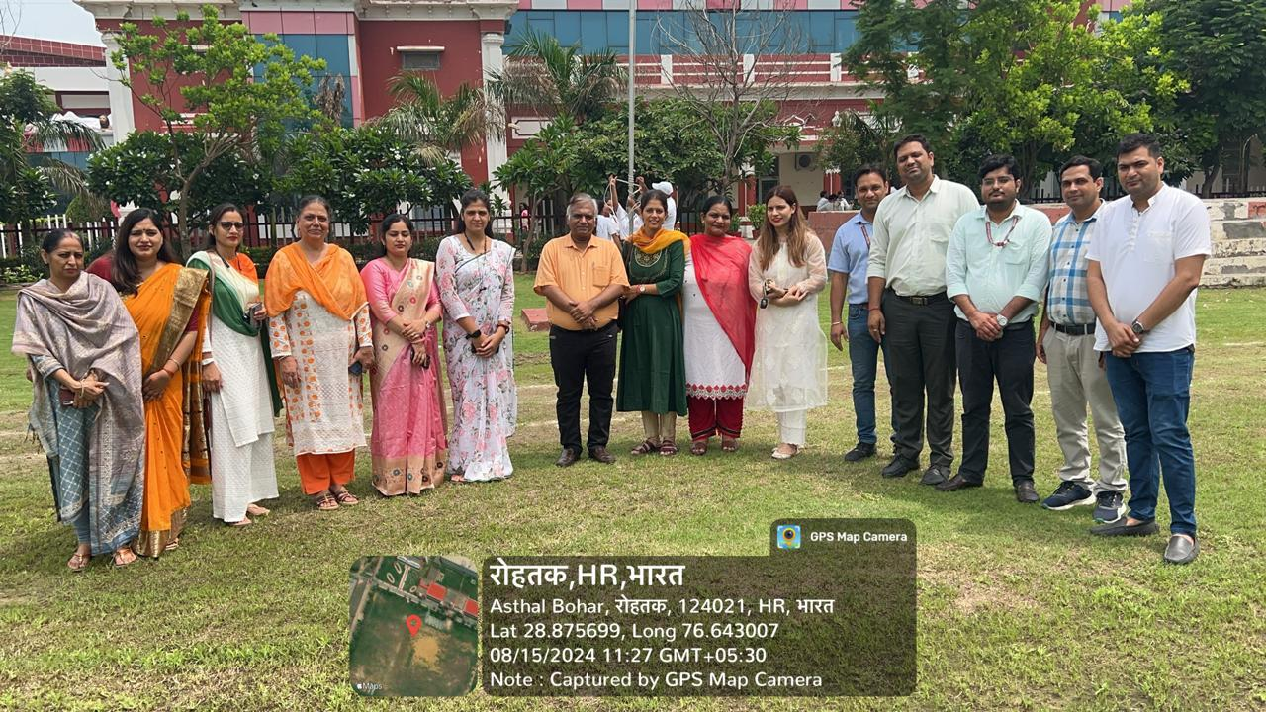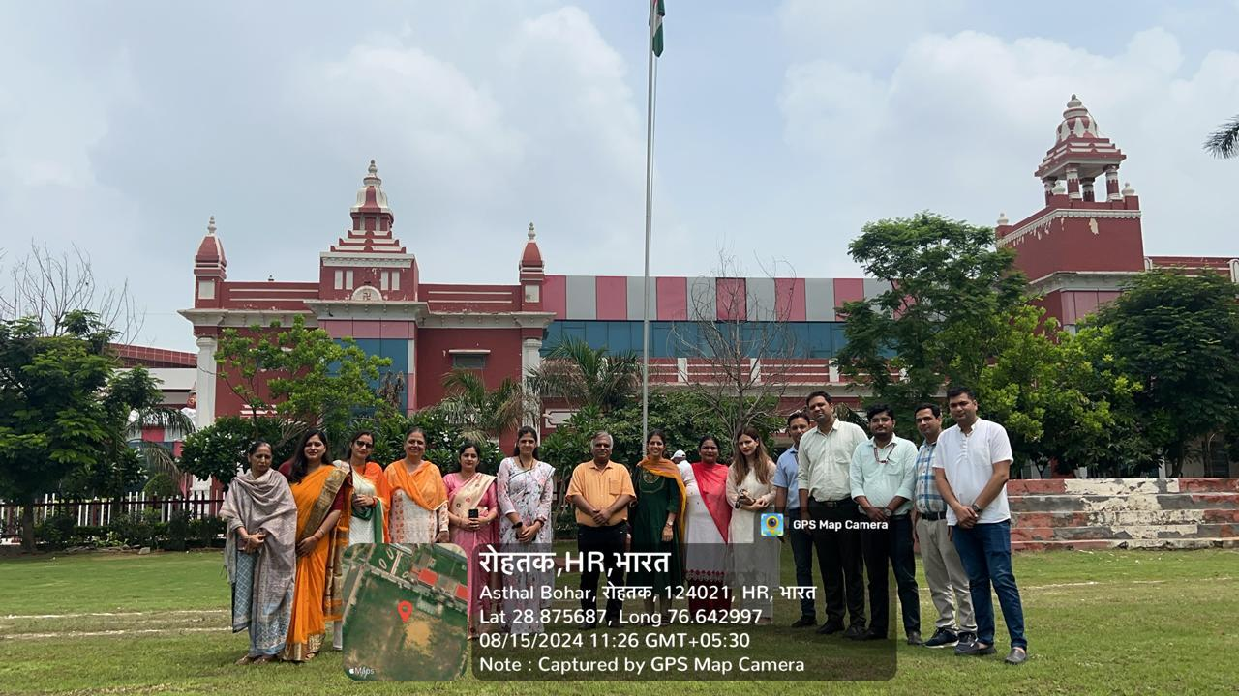Following the flag unfurling, a vibrant cultural program was organized by the Dean Student's Welfare & Faculty of Engineering. Students from various departments showcased their talents through captivating performances that highlighted our nation's rich cultural heritage.

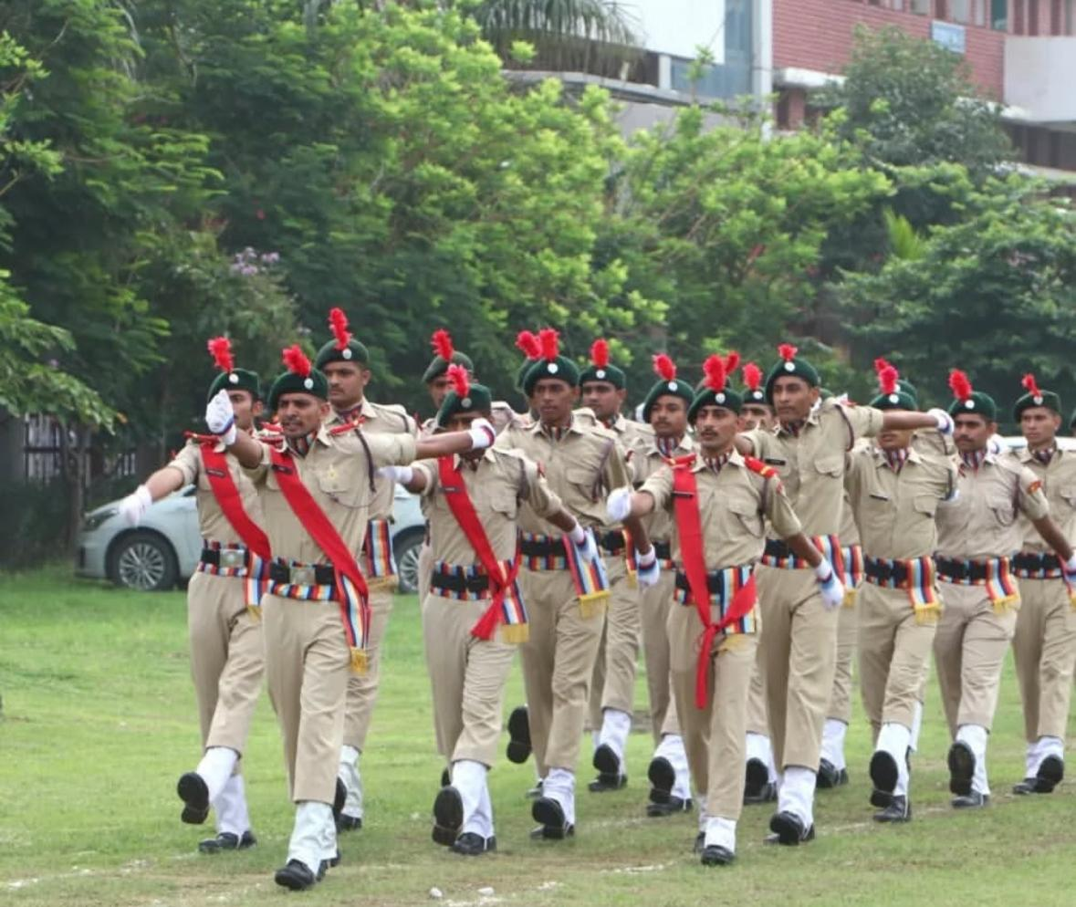

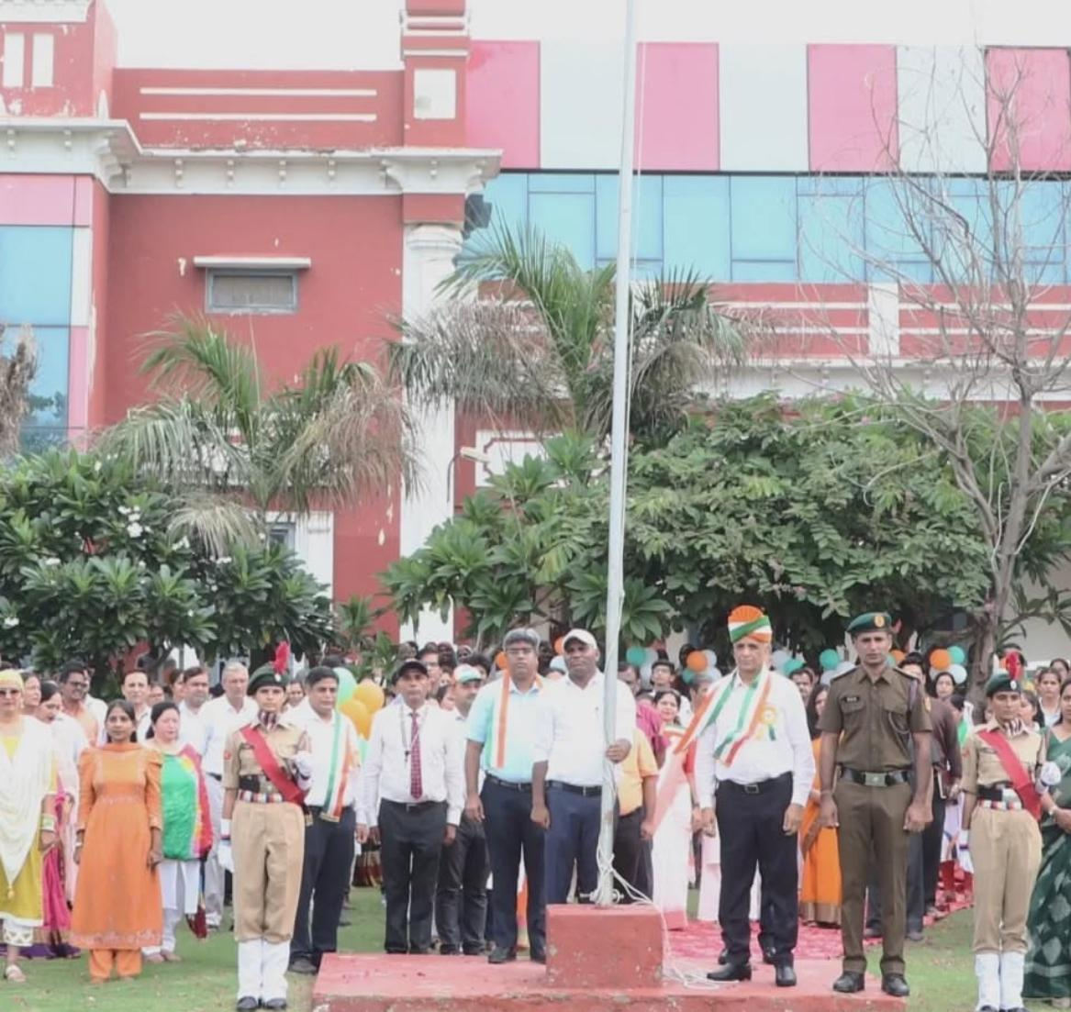

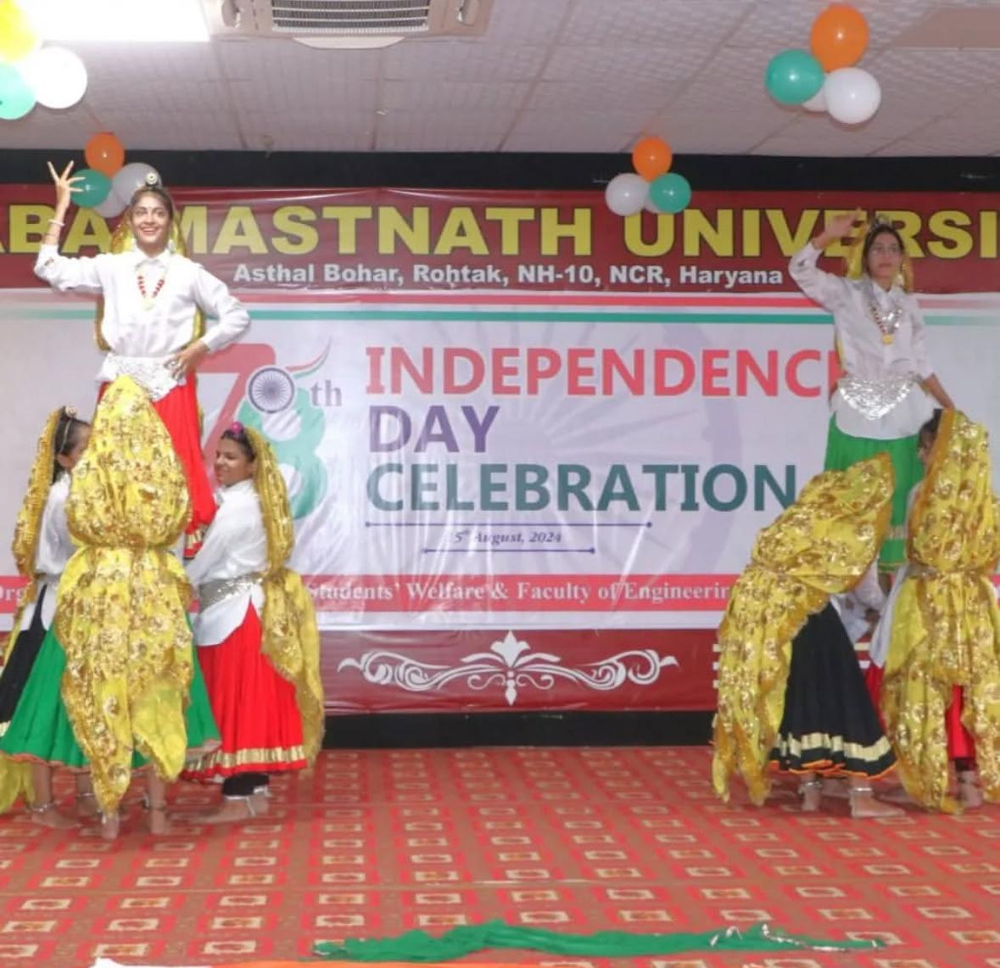

A heartfelt salute to everyone who made this day special! Let's continue to strive for a brighter, stronger, and more united India!